Winona State University Revenue Share Summer Model
Introduction
Summer Session has served an increasingly important academic function at Winona State University over the last decade. Since WSU adopted the current revenue share summer model in 2013, summer course offerings have increased in numbers and diversified in delivery. As a result, summer enrollments have been consistently healthy, even as overall enrollment at the institution has declined.
When the summer revenue share model was conceptualized and piloted, a task force comprised of faculty and administrators laid the groundwork that would allow the model to run smoothly. From their work came the standardization of summer start dates and class times and a set of guidelines that ensure the integrity and success of the model for departments that participate and for Winona State as a whole.
Purpose
The goal of Summer Session is to serve the academic needs of students. The purpose of the revenue share model is to give departments a financial incentive to offer summer courses that meet student needs. Courses that meet enrollment targets provide financial resources for the university, and this model returns a portion of those resources directly to the departments. Courses that meet the academic needs of students but generate lesser enrollment can also be offered through this model with dean’s approval.
Course Offerings
Departments will determine which courses will be offered and who will teach in accordance with Article 13 of the Master Agreement.
Departments are asked to have their Summer Session course offerings listed in Student eServices by the time students receive advising for the spring semester (October).
Enrollment Targets
The goal of the revenue share model is for every course that runs to produce a net financial gain for the university. Generally, undergraduate courses should enroll no fewer than 15 students and graduate courses should enroll no fewer than 10 students to ensure a net gain. This applies to most courses, regardless of the number of credits, method of instruction, or faculty salary. Laboratory and studio courses may have different enrollment requirements. The revenue share model does NOT include travel study courses, independent studies, internships*, or other courses within self-supporting programs. Such courses are referred to as Non-Revenue Model (NRM) courses.
Consistent with setting enrollment caps during the academic year, deans and departments (usually represented by the chair) will discuss appropriate class caps, scheduling, and cancellation of summer courses with deans making the final decision.
* Internships run on a separate share model that is covered later in this document.
Decisions on Which Courses Will be Offered
Courses that meet the minimum enrollment targets three weeks prior to the start date of the course are approved to be offered.
Courses that have enrollments lower than the minimum requirements three weeks prior to the start date of the course are brought forward to the appropriate college dean to determine whether or not the course should run at a loss. The go/no go decision process is typically done in consultation with the appropriate department chair. Revenue share model courses that will not produce a net gain for the university will count against the final distribution of revenue released to the department.
If the decision is made that a course cannot be offered due to insufficient enrollment, the course will be cancelled by the department and the college will work with the Registrar’s Office or other staff to contact students enrolled in the cancelled course. The department can advise affected students of other course offerings that may meet their academic needs.
Revenue Sharing
The Summer Session Revenue Share Model shares profits generated by a department directly with that department. Instead of receiving an allocation that limits the number of courses a department can teach, the model allows departments to teach as many classes as faculty interest and student demand warrant. Ideally, this will give departments greater flexibility in course scheduling and greater control over profitability.
For purposes of the revenue share model, the total cost of a summer course is calculated as the overload rate plus fringe of the faculty member assigned to teach the course. The tuition revenue is calculated as the number of enrolled students multiplied by the Minnesota tuition rate times the number of credits. The net gain or loss of a course is the total tuition less the total cost of the faculty member’s overload rate plus fringe. A department offering a course producing a net gain will share the revenue according to the distribution formula described below (see chart). A department offering a course producing a net loss will be solely responsible for the net loss (except for courses taught by the chairperson as a part of their summer duties as described below).
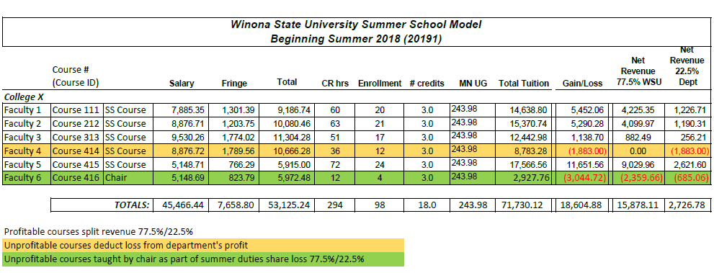
Department Chairpersons
For a chairperson teaching in the summer as part of the contractually specified additional duty days, the salary used for revenue calculations will be the summer salary rate as specified in Article 13 of the IFO Master Agreement. The net gain or loss from such a course will be distributed according to the model of revenue sharing (see chart). The revenue distribution for a department chairperson teaching a course outside of the contractually specified additional duty days will be treated as any other faculty member for the purposes of this model.
Revenue Distribution
The revenue share model attempts to balance the financial needs of the university while providing departments an incentive to offer courses that students will want to take. Since Summer 2018, the model has distributed 22.5% of revenue generated by a department back to them.

Internship Share Model
In 2017, an addendum to the original Summer Session Revenue Share Model was approved through the shared governance process to create a separate and complimentary model for summer internships. This model does not include field trips, practicum experiences or independent studies.
Under the Summer Internship Share model, 75% of the net revenue from summer internship credits is distributed to the university; 25% of the net revenue is distributed to the academic department generating the revenue.
- If a chair’s internship supervision is Part-of-Load (POL), that will not be included in this internship model.
- If a chair’s internship responsibilities are above and beyond POL, that will be included in the internship model.
- For faculty who provide internship supervision without any compensation, their salary will be entered as zero; however, the credits generated through internship tuition revenue will be calculated in the revenue share distribution.
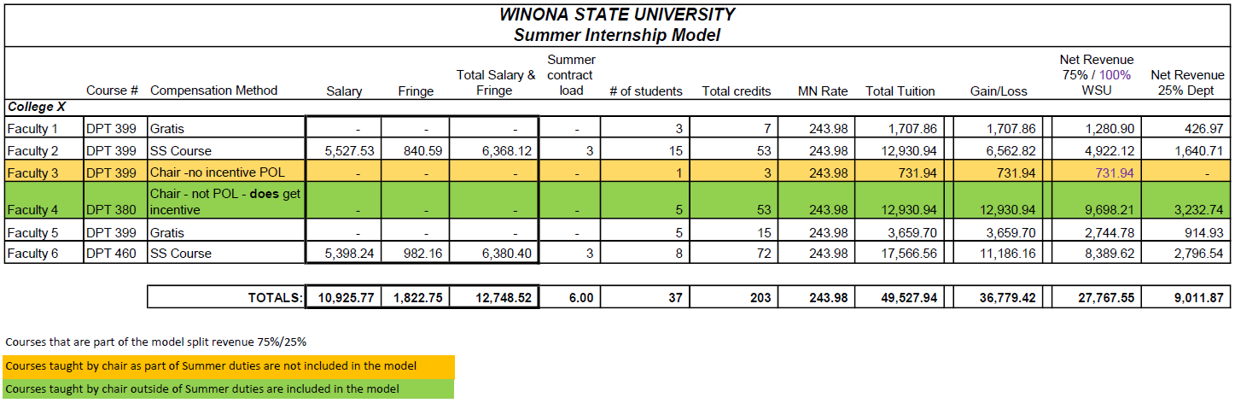

Revenue Management/Use
With both of these models, revenue shared with a department is tuition-generated and will be managed under the same principles and decision-making as a department’s operating budget. Summer funds shall be spent in accordance with the IFO/MinnState Master Agreement, WSU, and Minnesota State guidelines, regulations, and laws that govern operating budgets within departments. Unspent balances in the summer incentive revenue account will automatically carry forward to the next fiscal year.

Term Course Form (TCF) and Course Approval Process
All Term Course Forms (TCFs) are created and submitted by OAS staff at the academic department level. It is important that all courses that are intended to be Revenue Model courses are indicated as receiving funding from ACE/Extension during the TCF process. Courses that are Non-Revenue Model (NRM) should not indicate that funding is coming from ACE/Extension. Any information regarding split credits or multiple instructors (e.g., pyramided courses or separate lecture and lab instructors) should be noted on the TCF to ensure accuracy in salary calculations and assignment creation.
Once courses are published and released by the Registrar’s Office, ACE will verify that Revenue Model courses are entered into FWM correctly and will release assignments for dean’s approval as go/no-go decisions are made. ACE does NOT review or push forward Non-Revenue Model courses. The OAS from each department should doublecheck the accuracy of these assignments in FWM and release them for dean’s approval.
Once an assignment for a Revenue Model course is released and approved by the appropriate dean, no changes to that assignment should be made without consultation with ACE. If what is released requires discussion prior to approval, it is the responsibility of the appropriate dean to talk through concerns and/or assignment modifications with ACE. Modifications to Revenue Model course assignments should not be made by a dean or college/department OAS. If modifications are made without consultation with ACE and those modifications do not fall within the recommendations and standards of the Revenue Share Model, shares from that course will not be disbursed to the corresponding department and any negative repercussions will be solely felt at the college/department level.
Cost Center Usage
Expenses for all courses, unless they are offered out of a self-support program, should be billed to a 230xxx account. This includes classes that are part of the revenue share model and those that are not (such as internships, independent studies, field experiences, etc.). Expenses for courses that reside within a self-support or 75/25 program should be billed to the appropriate 257xxx account.
Questions related to cost center usage for Summer Session courses should be directed to Melissa Soppa in the Finance Office.

Summer Schedule
Summer courses should typically be scheduled as follows:
- May Term. This is a three-week, 15-class-day session that begins after Commencement. Three-credit hour classes will typically meet Monday-Friday for two hours and 40 minutes per day for 2400 contact minutes (allows time for a break during the class period).
8:00 am to 10:40 am
11:00 am to 1:40 pm
2:00 pm to 4:40 pm
5:00 pm to 7:40 pm
- Summer Session I. This is a five-week, 20 class day session, that begins following the end of May Term. Classes will typically meet Monday-Thursday for two hours per day for five weeks, but classes may also be scheduled to meet Monday-Friday for two hours for four weeks (2400 contact minutes).
- Summer Session II. This is a five-week, 20 class day session that begins following the end of Summer Session I. Classes will typically meet Monday-Thursday for two hours per day for five weeks, but classes may also be scheduled to meet Monday-Friday for two hours per day for four weeks (2400 contact minutes).
- Full Summer Term. This is a 10-week, 20 class day session that begins at the start of Session I and ends with the conclusion of Session II. Classes will typically meet two days per week for the 10 weeks (2400 contact minutes).
Course scheduling for Summer Session I, II, and Full Term:
7:30 am to 9:30 am
9:40 am to 11:40 am
11:50 am to 1:50 pm
2:00 pm to 4:00 pm
4:10 pm to 6:10 pm
6:20 pm to 8:20 pm

Courses that are not three credits should be scheduled so that they align with the recommended times as closely as possible. When an alternative class time is needed to address pedagogical needs, faculty and deans will work together to determine best alternative scheduling.

